PUBLIC HEALTHCARE AWARNESS CAMPAIGN

3rd – AI&DS

M.A.M COLLEGE OF ENGINEERING

TEAM MEMBERS,

A.REJOE BLESY

S.SIVA SANKARI

N.YASMEEN NILOFAR

M.SEEMA

A.AYISHA

PROGRAM:

random

import time

# Simulate a smartwatch import measuring pulse rate

def measure_pulse_rate():

return random.randint(60, 120) # Simulated pulse rate data

def alert_high_pulse_rate(threshold):

while True:

pulse_rate = measure_pulse_rate()

print(f"Current Pulse Rate: {pulse_rate} BPM")

if pulse_rate > threshold:

print(f"High Pulse Rate Alert! Pulse rate is above {threshold} BPM.")

# Add code here to send an alert to the user (e.g., notifications)

time.sleep(10) # Adjust the interval as needed

if _name_ == "_main_":

threshold = 100 # Set the pulse rate threshold for alerting

alert_high_pulse_rate(threshold)

PROGRAM:

# Import necessary libraries

import pandas as pd

import numpy as np

from sklearn.model_selection import train_test_split

from sklearn.ensemble import RandomForestClassifier

from sklearn.metrics import accuracy_score, classification_report

# Load your medical dataset

data = pd.read_csv('medical_data.csv') # Replace 'medical_data.csv' with your dataset file

# Data preprocessing

# Handle missing values, encode categorical variables, etc.

# Define features (X) and target (y)

X = data.drop('target_variable', axis=1) # Adjust 'target_variable' to the name of your target column

y = data['target_variable']

# Split data into training and testing sets

X_train, X_test, y_train, y_test = train_test_split(X, y, test_size=0.2, random_state=42)

# Build a machine learning model (Random Forest in this example)

model = RandomForestClassifier(n_estimators=100, random_state=42)

# Train the model

model.fit(X_train, y_train)

# Make predictions on the test set

y_pred = model.predict(X_test)

# Evaluate the model

accuracy = accuracy_score(y_test, y_pred)

report = classification_report(y_test, y_pred)

# Print results

print(f'Accuracy: {accuracy}')

print(report)

OUTPUT:

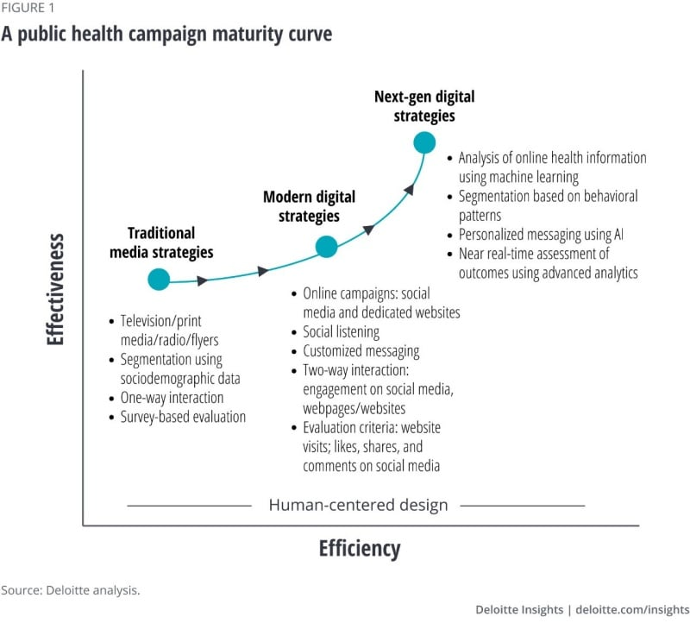

OUTPUT:

